**LAB ASSIGNMENT**

**Name: Deepankar Sharma**

**Student ID: 233512013**

**Course Code: OMC308 Last Date of Submission: 31/12/24**

**Course Title: Mobile Application Development Laboratory Maximum Marks: 30**

**Program 1**  
Create an Android application that displays the message:  
*“Welcome to Graphic Era University MCA”* on the screen.

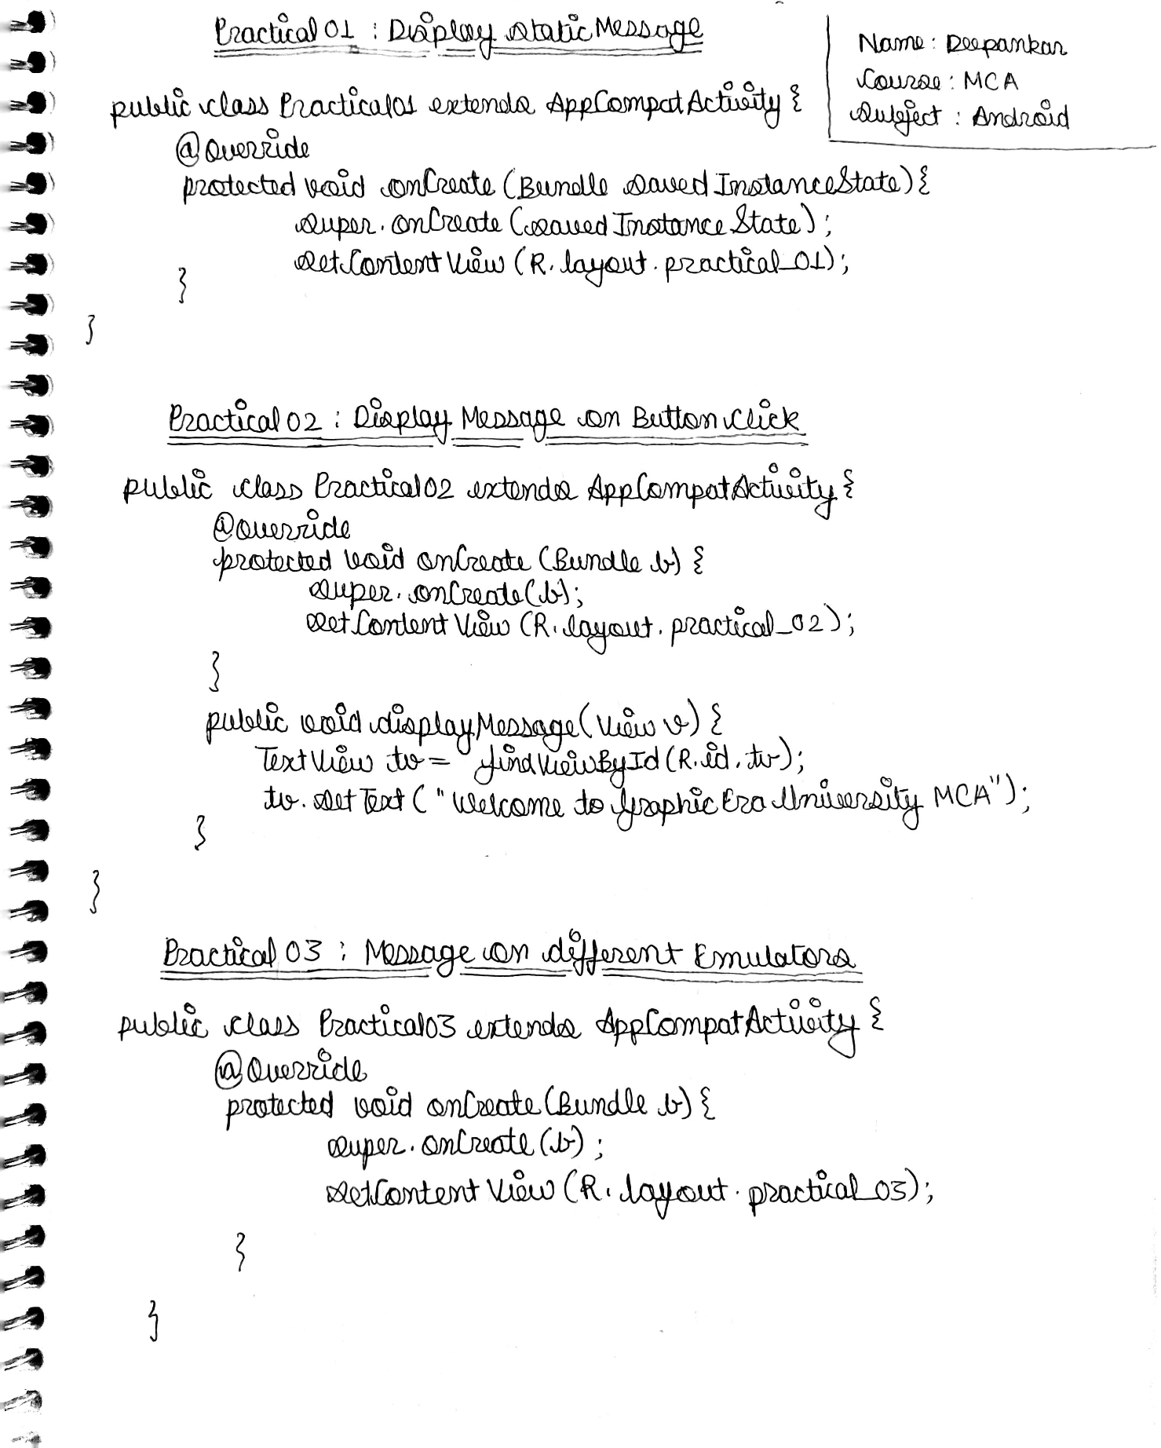

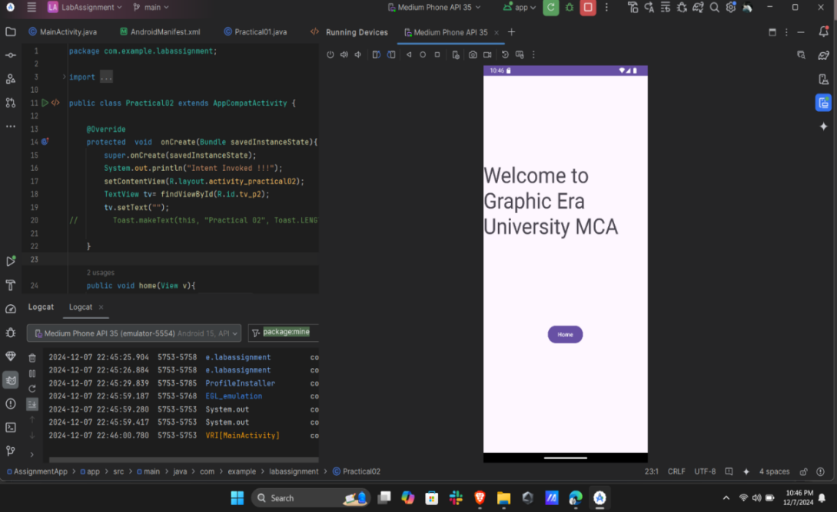

Practical 01

**Program 2**  
Create an Android application that displays the message:  
*“Welcome to Graphic Era University - MCA”* when a button is clicked.

|  |  |
| --- | --- |
| IMG_256 | IMG_256 |

Practical 02

**Program 3**  
Create an Android application to display the message:  
*“Welcome to GEU - learning Android Application Development - MCA”*  
and execute the application using different emulators.

|  |  |
| --- | --- |
| IMG_256  Medium Phone API | IMG_256  Pixel 6 Pro |

**Program 4**  
Illustrate with a suitable example the use of **Toast** to display a message in an Android application.  
*[The message display should wait for a long time]*

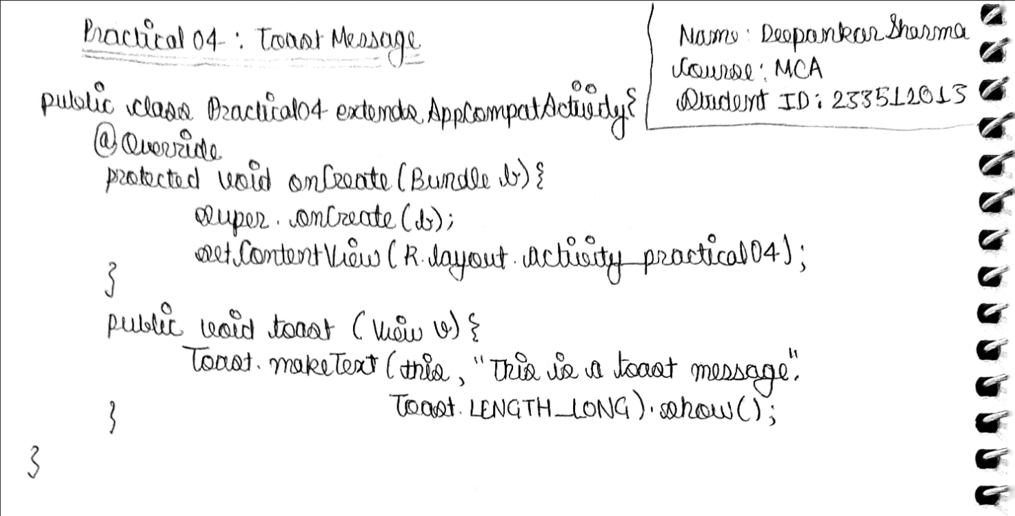

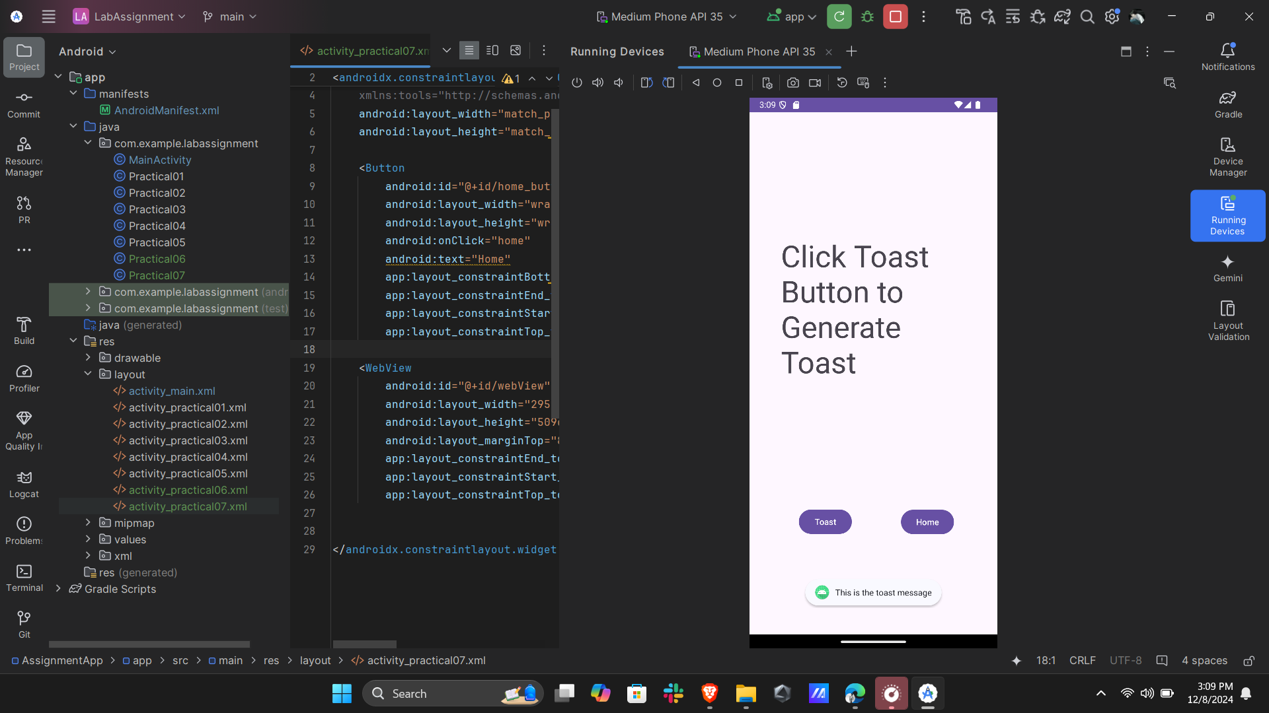

Practical 04

**Program 5**  
Create an Android application for designing a simple calculator with the following basic functionalities:Addition, , Subtraction , Multiplication, Division

Use controls like **Buttons**, **TextViews**, and **EditTexts**.

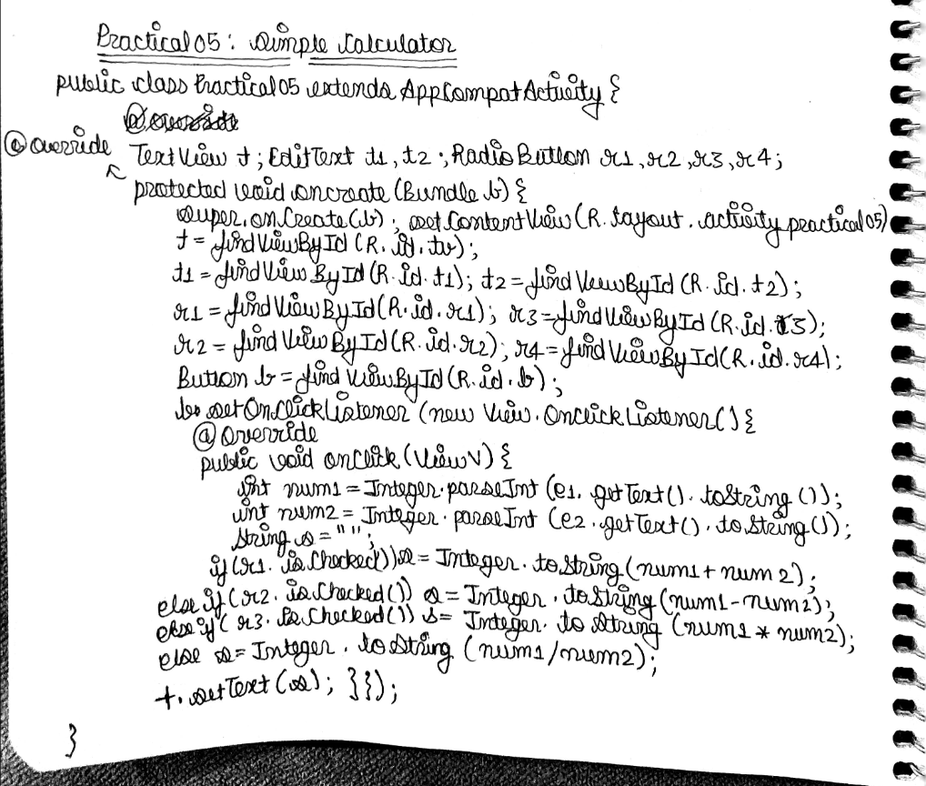

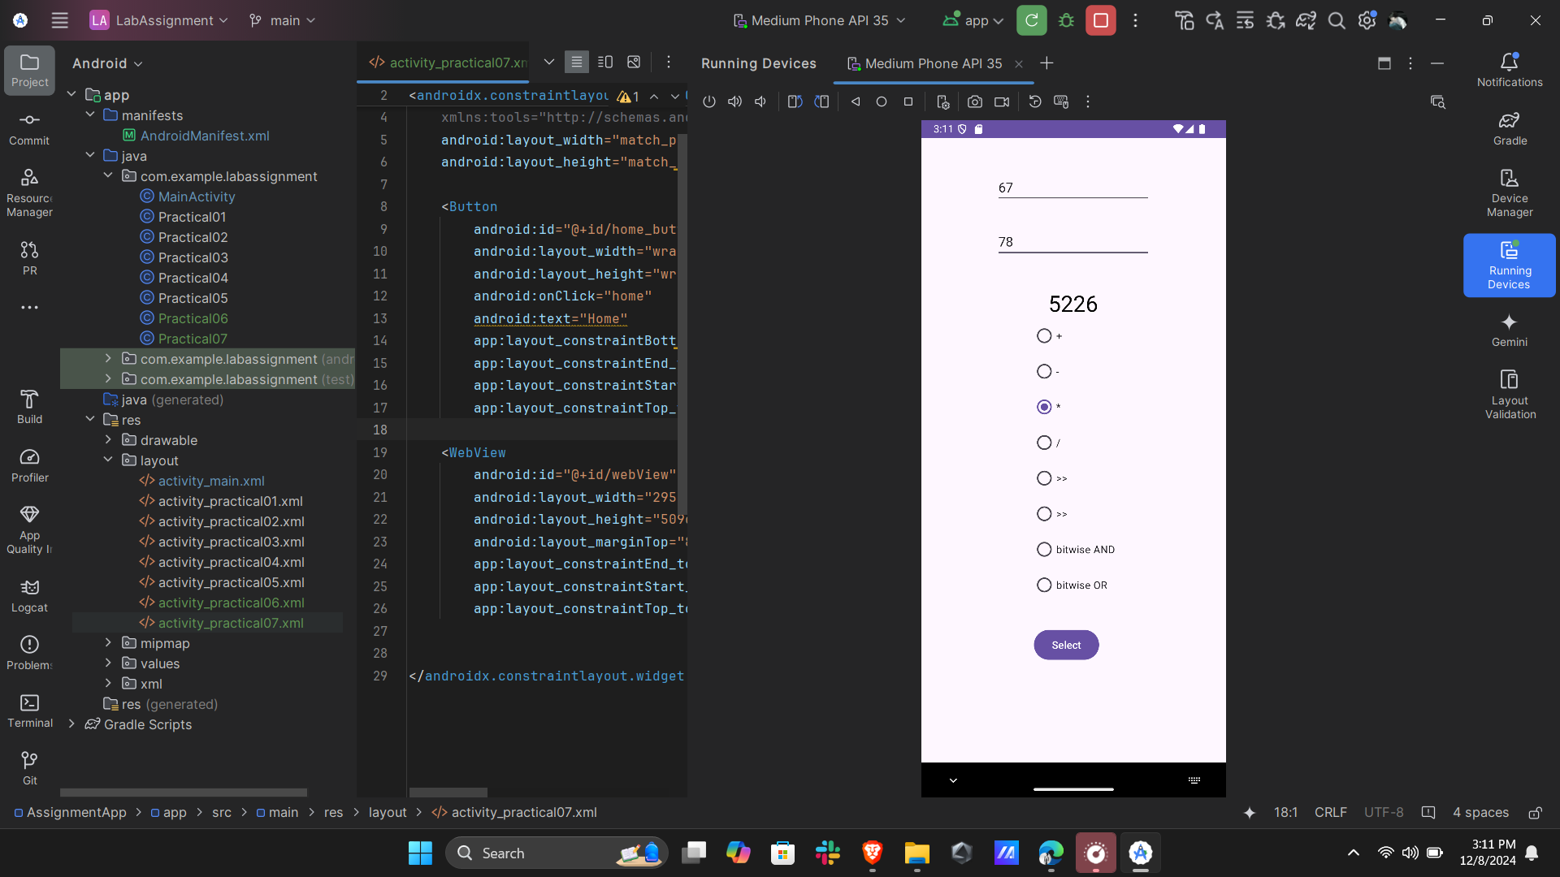

------------------------------------------------------------------------------------------------------------

**Program 6**  
Illustrate with a suitable example the use of **Intents** for linking activities.  
*[At least two activities should be used]*

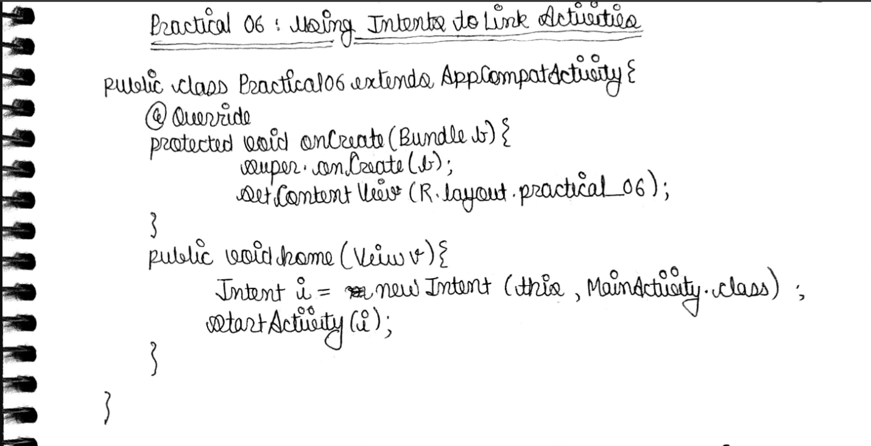

|  |  |
| --- | --- |
| IMG_256  Main Activity | IMG_256  Intent Activity |

------------------------------------------------------------------------------------------------------------

**Program 7**  
Illustrate with a suitable example the use of **Intents** for navigating to a website.  
*[Navigate to Graphic Era University Website]*

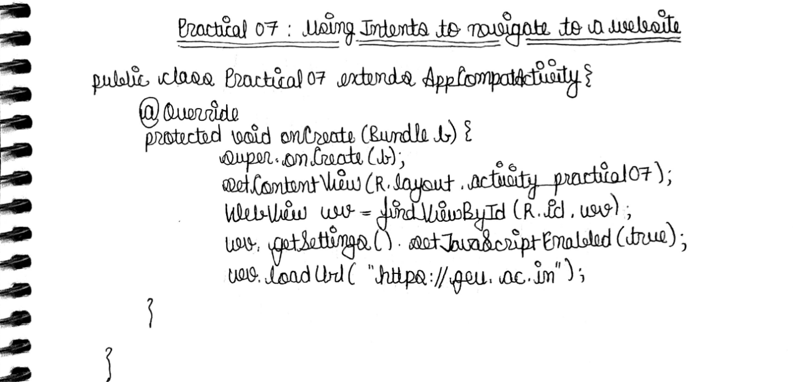

|  |  |
| --- | --- |
| IMG_256  Main Activity | IMG_256  Intent Activity |

-----------------------------------------------------------------------------------------------------------

**Program 8**  
Create an Android application that demonstrates the use of **Relative Layout** in Android by using appropriate views to create a login form.

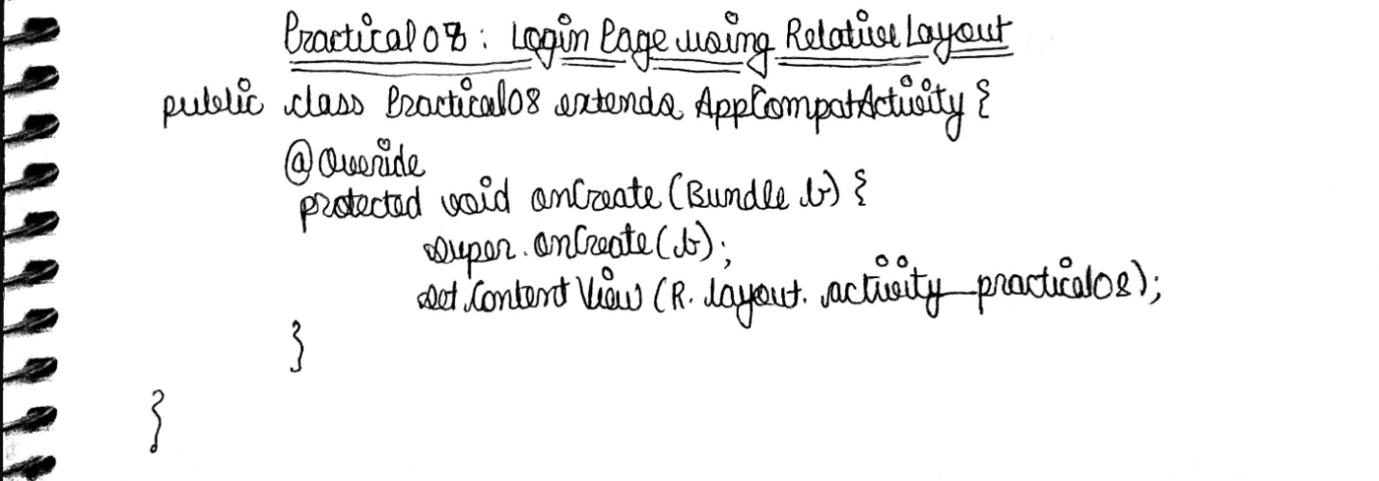

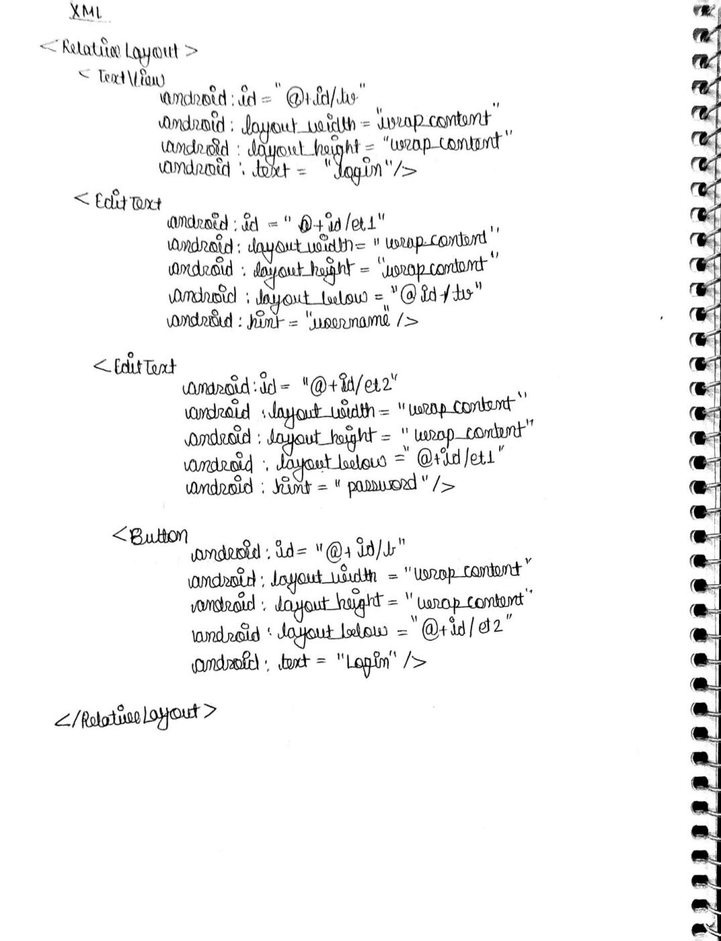

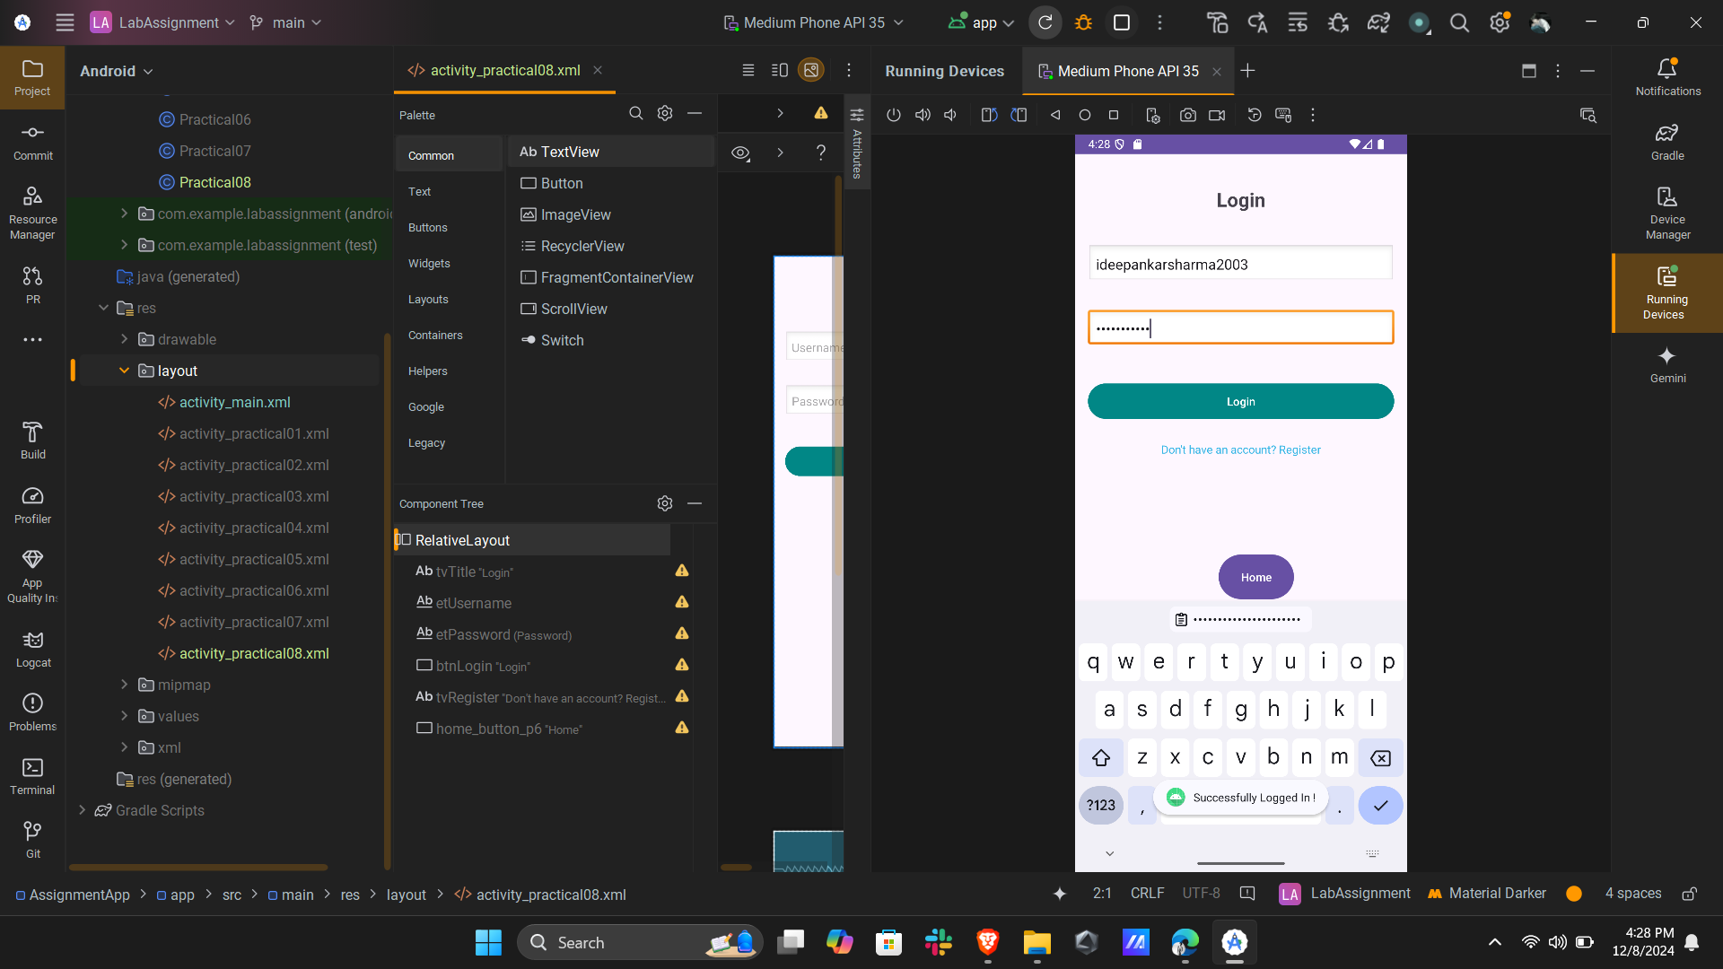

**Program 9**  
Create an Android application that demonstrates the use of appropriate layouts and views to create a Registration Form *[For intercollege sports events]* and display the message:  
*“Registration is successful”* on the click of a Submit button.

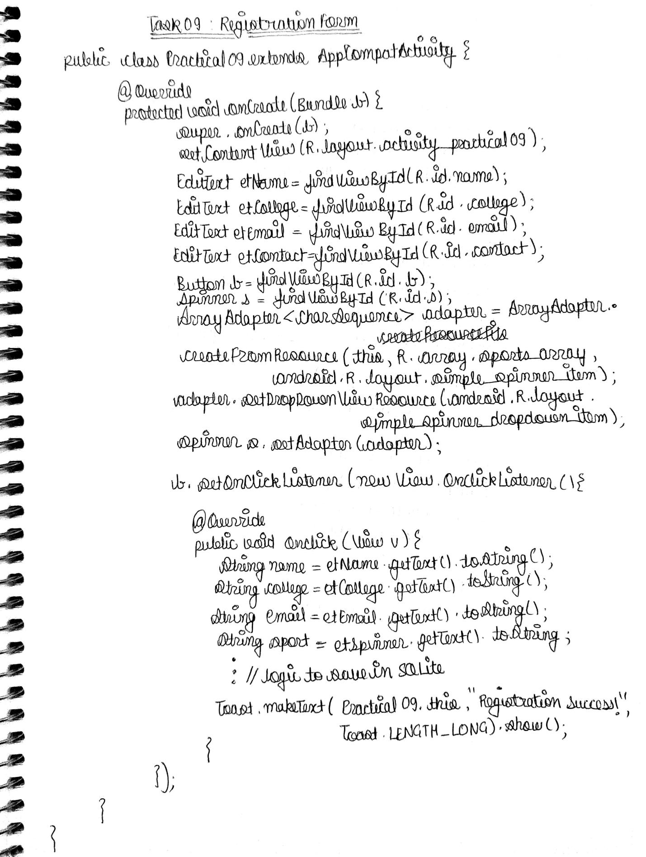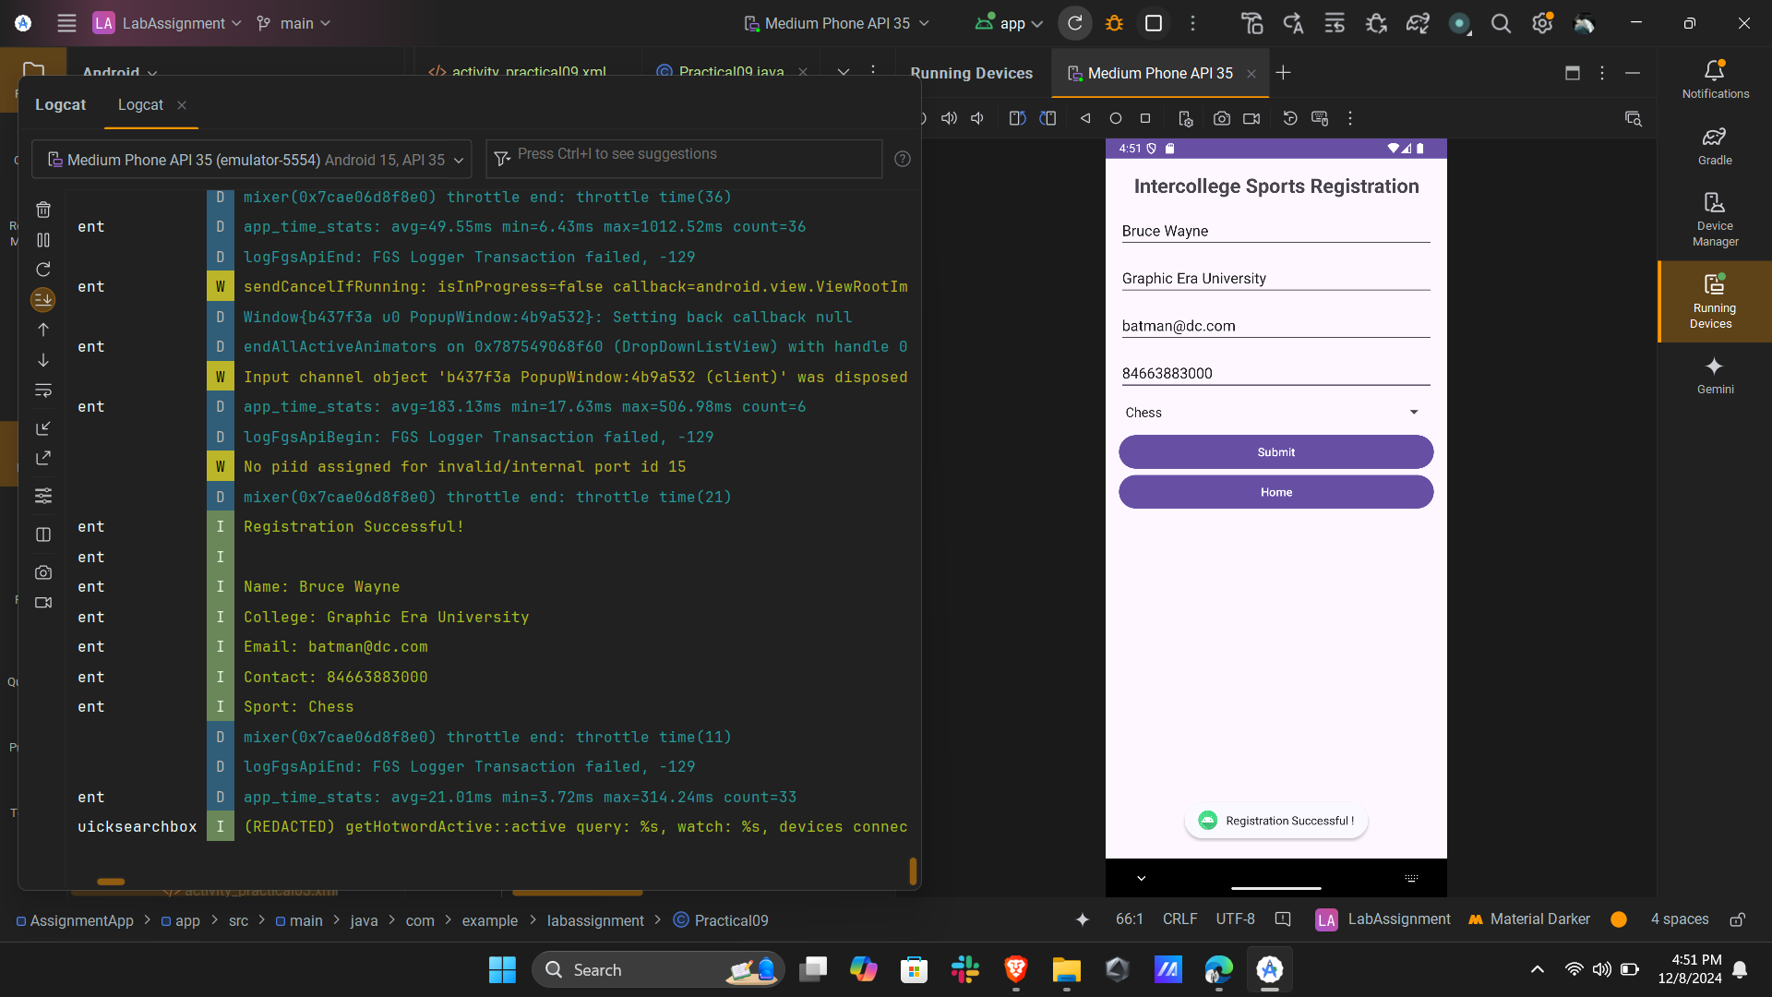

**Program 10**  
Illustrate with a suitable example the use of graphics for displaying the following shapes:

1. Circle 2. Triangle 3. Rectangle

